Rofiat.ayagbe@womentechsters.org

Rofiat Ajagbe

PRACTICAL ACTIVITY 3

2021

**Practical Activity 3 On Linux Administration**

Part 1: of Practical Activity Week 3

1.List all processes with **ps -A**

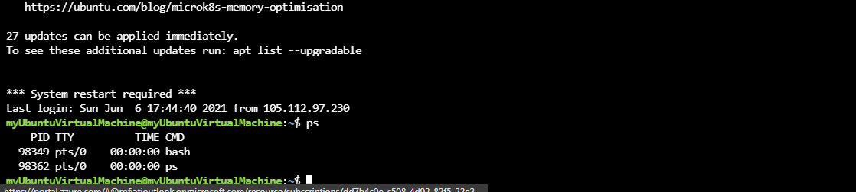

2.Display information about processes **ps aux**

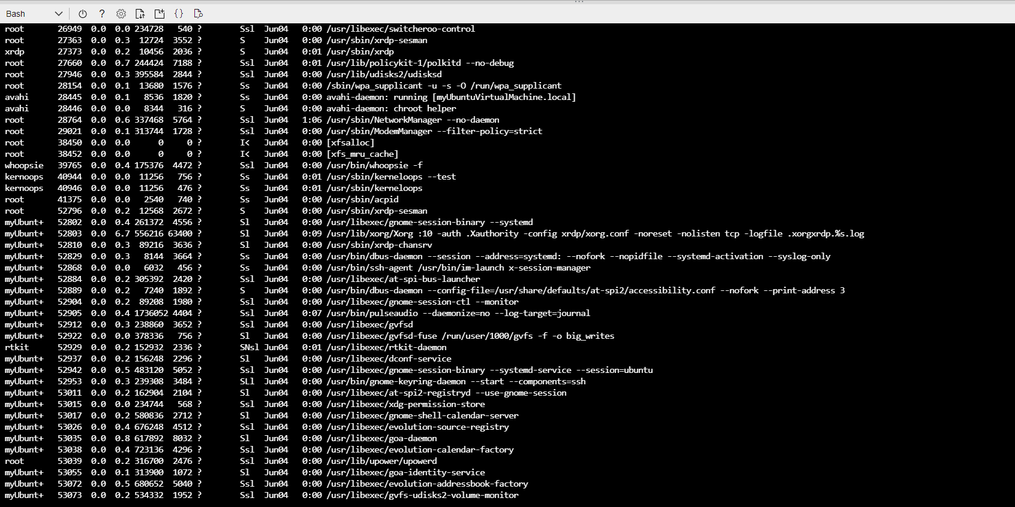

3.Display global priority of a process **ps -o pri /ps ec**

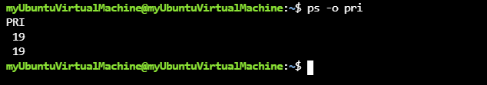

4.Change priority of a process with default arguments **ps al**



5.Display Virtual Memory Statistics **vmstat**

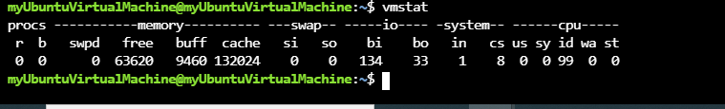

6.Display System events information **cat /proc/meminfo**

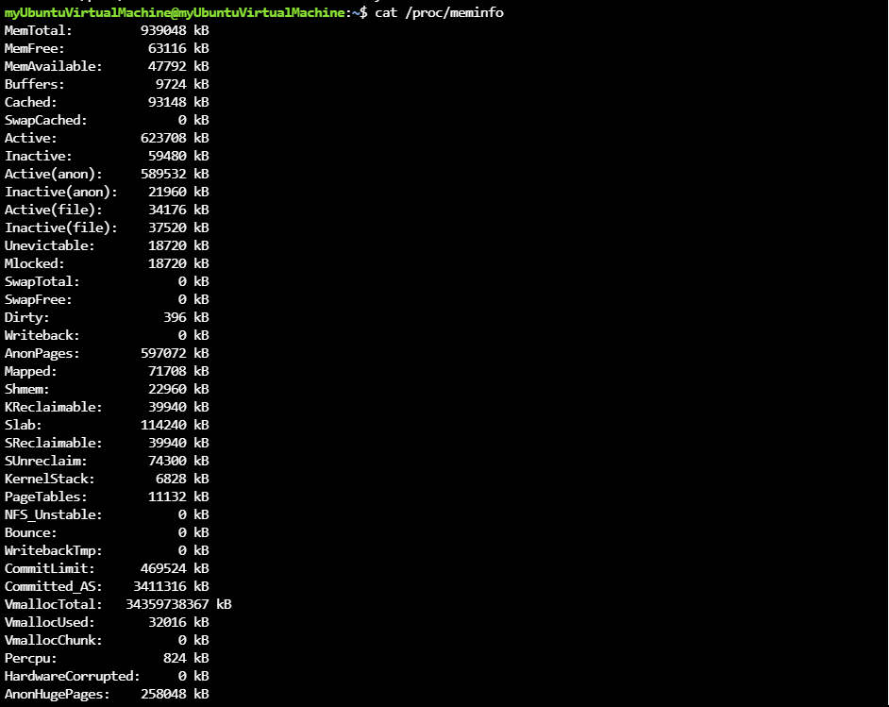

7.Display swapping statistics **free -h**

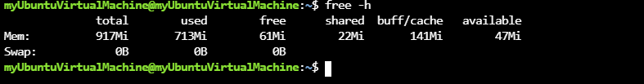

8.Check file access statistics **ps -ecl**

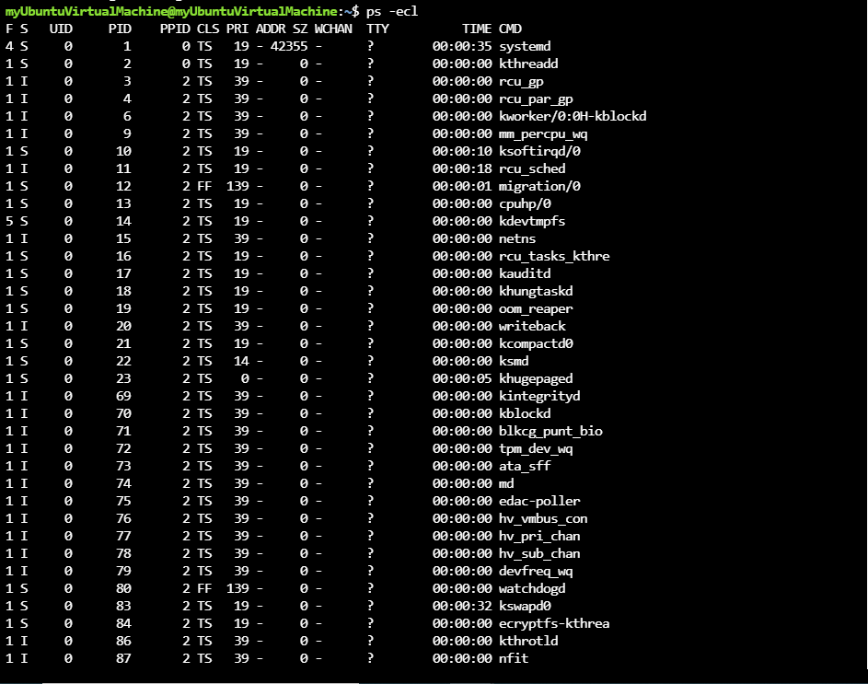

9.Check buffer activity statistics\ **free -m**

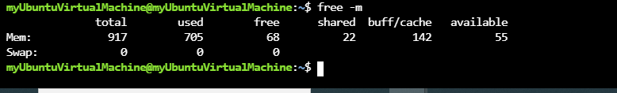

10 Check disk activity statistics **df**

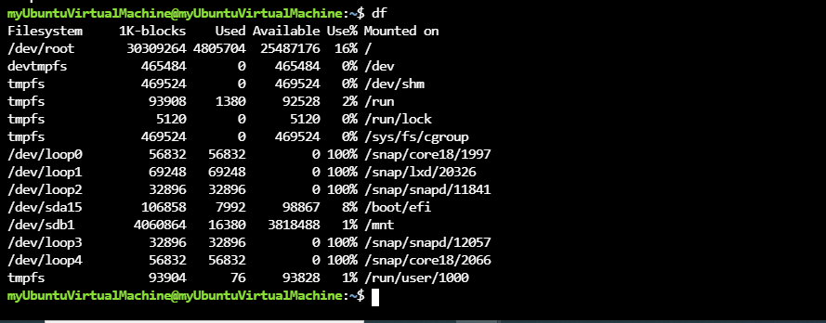

11 Check inter process communication statistics **ipcs -a**

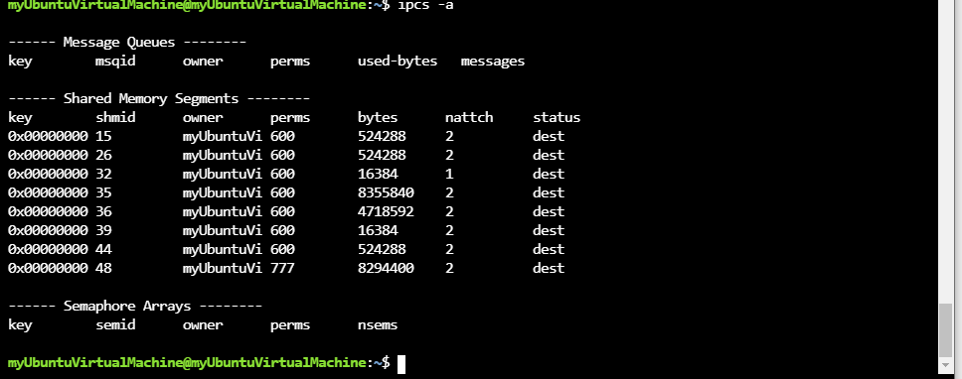

12.Check unused memory in the server **free**

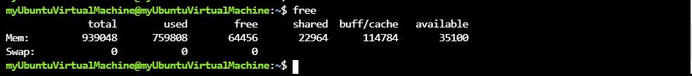

13.Check swap activities **grep Swap /proc/meminfo**



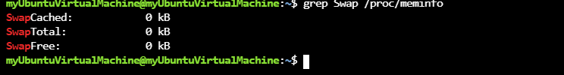

PART 2 Practical Activity Week 3

Create a user account called user 1 and another user 2

1.sudo adduser 1

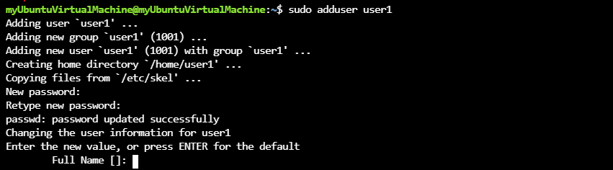

2.sudo adduser2 password protected

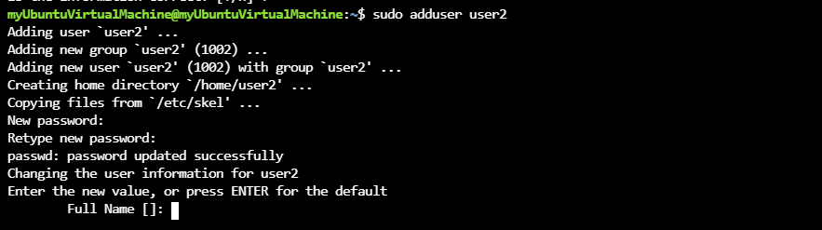

3.Logout

4.Create a testfile in testdir

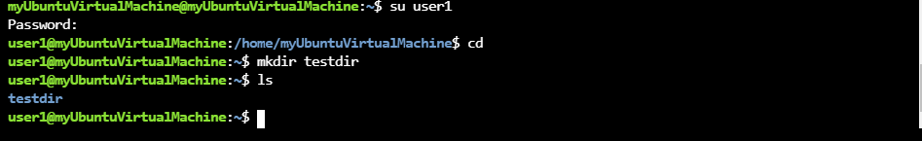

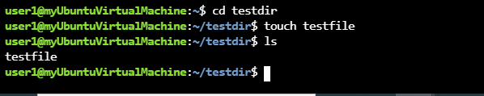

6.Verify the ownership and group of testfile

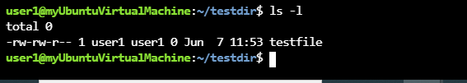

7.Switch to superuser account

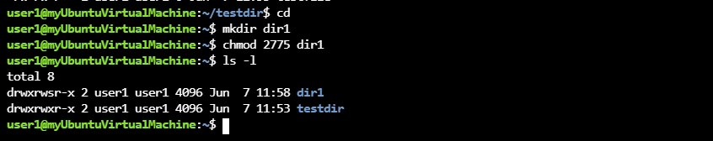

8. Create directory dir1



9.Set stickybit on dir1

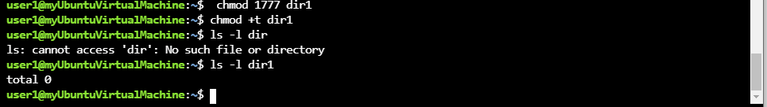

10.logout and login as a normal user user1  


11.Create a file user1 in dir1

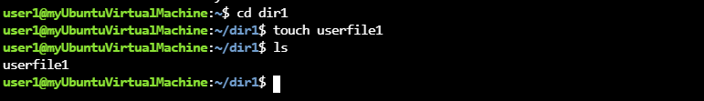

12 Login as a different user user2

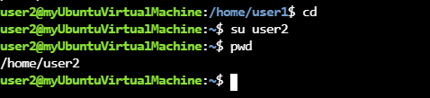

13.Try to edit or remove file **vi userfile1**

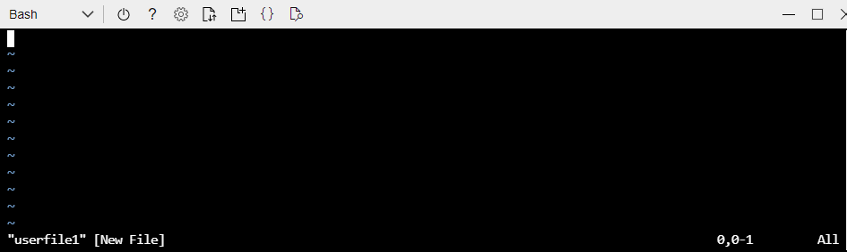

14.Temporarily disable user logins